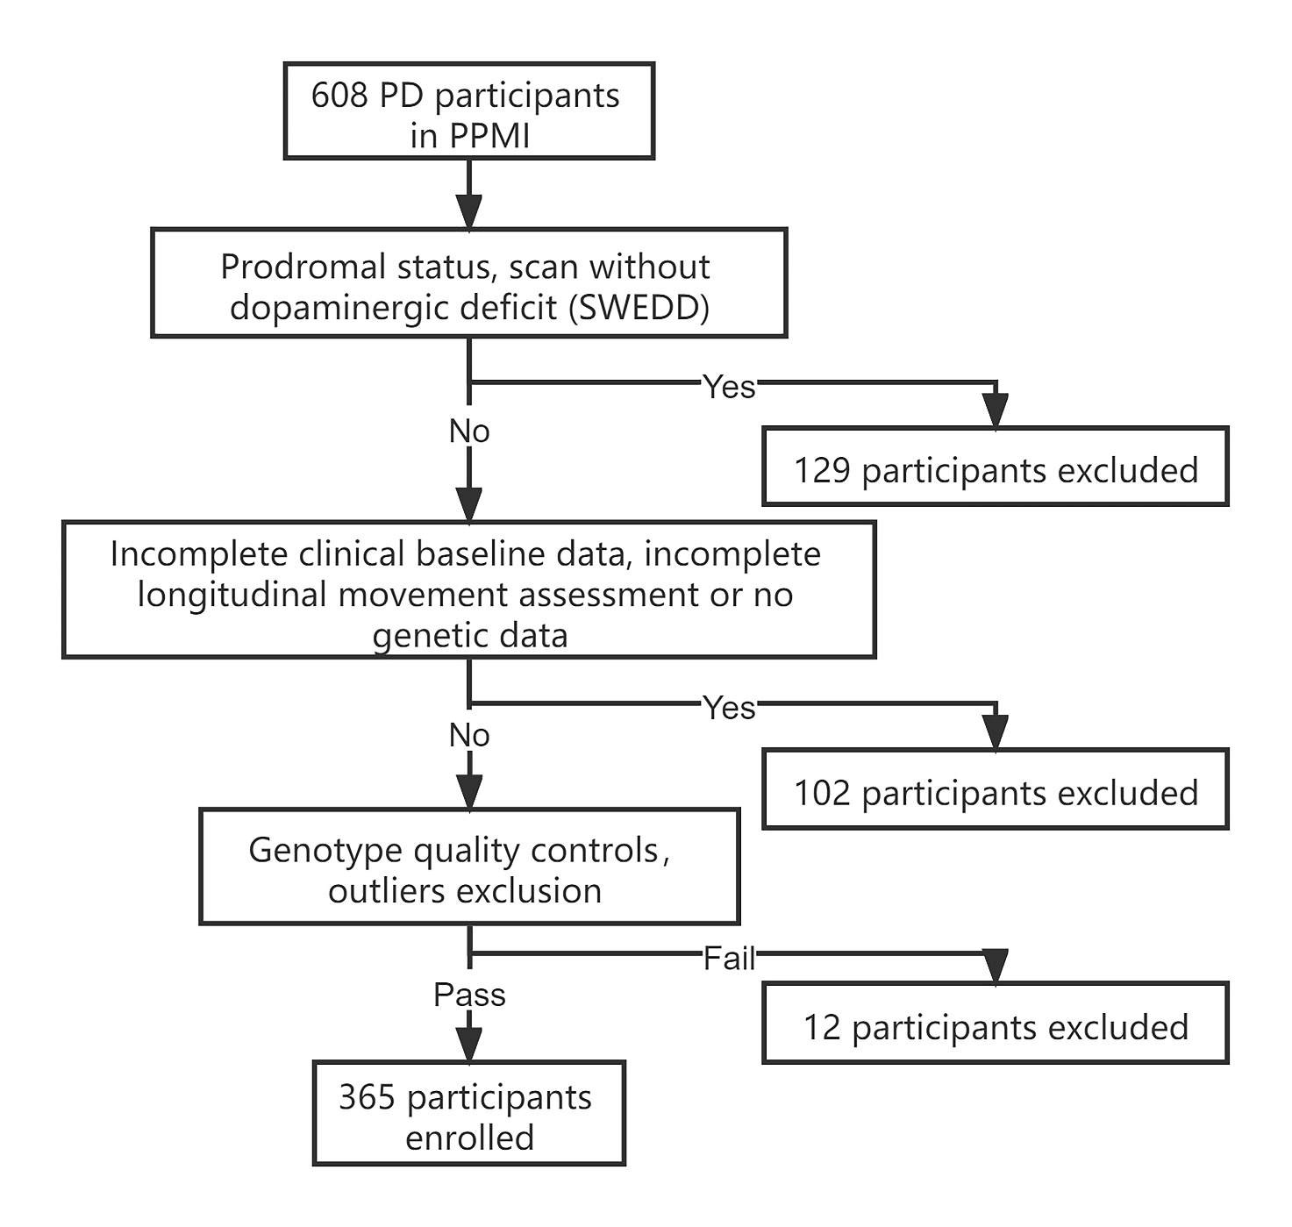
Supplementary Fig. 1. Case selection flow diagram. There was a total of 608 PD participants in PPMI by September 2020 when the data was downloaded. After three steps of elimination procedures, a total of 365 participants were selected in this study.

Supplementary Table 1. Summary of genetic variants selected in this study.
No. | SNP | CHR | Position (Bp) | EA/AA | EA frequency | Related Genetic Loci
1 | rs823118 | 1 | 205723572 | C/T | 0.315 | NUCKS1
2 | rs10797576 | 1 | 232664611 | T/C | 0.137 | SIPA1L2
3 | rs4653767 | 1 | 226916078 | C/T | 0.315 | ITPKB
4 | rs6430538 | 2 | 135539967 | T/C | 0.488 | ACMSD
5 | rs34043159 | 2 | 102413116 | C/T | 0.352 | IL1R2
6 | rs353116 | 2 | 166133632 | T/C | 0.385 | SCN2A
7 | rs6808178 | 3 | 28705690 | T/C | 0.378 | LINC00693
8 | rs115185635 | 3 | 87520857 | C/G | 0.036 | CHMP2B
9 | rs12637471 | 3 | 182762437 | A/G | 0.219 | MCCC1
10 | rs4073221 | 3 | 18277488 | G/T | 0.132 | SATB1
11 | rs12497850 | 3 | 48748989 | G/T | 0.347 | IP6K2
12 | rs34311866 | 4 | 951947 | C/T | 0.199 | TMEM175
13 | rs11724635 | 4 | 15737101 | C/A | 0.437 | BST1
14 | rs6812193 | 4 | 77198986 | T/C | 0.398 | FAM47E/SCARB2
15 | rs356182 | 4 | 90626111 | G/A | 0.375 | SNCA
16 | rs78738012 | 4 | 114360372 | C/T | 0.106 | CAMK2D
17 | rs11950533 | 5 | 134199105 | A/C | 0.104 | C5orf24
18 | rs2694528 | 5 | 60273923 | C/A | 0.115 | NDUFAF2
19 | rs12528068 | 6 | 72487762 | T/C | 0.285 | RIMS1
20 | rs997368 | 6 | 112243291 | A/G | 0.803 | FYN
21 | rs9468199 | 6 | 27681215 | A/G | 0.172 | ZNF184
22 | rs199347 | 7 | 23293746 | G/A | 0.368 | GPNMB
23 | rs591323 | 8 | 16697091 | A/G | 0.293 | FGF20
24 | rs2280104 | 8 | 22525980 | T/C | 0.367 | SORBS3
25 | rs13294100 | 9 | 17579690 | T/G | 0.371 | SH3GL2
26 | rs10748818 | 10 | 104015279 | A/G | 0.851 | GBF1
27 | rs10906923 | 10 | 15569598 | C/A | 0.306 | FAM171A1
28 | rs3793947 | 11 | 83544472 | A/G | 0.463 | DLG2
29 | rs329648 | 11 | 133765367 | T/C | 0.327 | MIR4697
30 | rs11610045 | 12 | 133063768 | A/G | 0.485 | FBRSL1
31 | rs76904798 | 12 | 40614434 | T/C | 0.132 | LRRK2
32 | rs11060180 | 12 | 123303586 | G/A | 0.450 | OGFOD2
33 | rs9568188 | 13 | 49927732 | T/C | 0.747 | CAB39L
34 | rs4771268 | 13 | 97865021 | T/C | 0.237 | MBNL2
35 | rs12147950 | 14 | 37989270 | T/C | 0·438 | MIPOL1
36 | rs11158026 | 14 | 55348869 | T/C | 0.307 | GCH1
37 | rs8005172 | 14 | 88472612 | T/C | 0.424 | GALC
38 | rs2414739 | 15 | 61994134 | G/A | 0.292 | VPS13C
39 | rs14235 | 16 | 31121793 | A/G | 0.397 | BCKDK/STX1B
40 | rs11343 | 16 | 19279464 | T/G | 0.454 | COQ7
41 | rs4784227 | 16 | 52599188 | T/C | 0.265 | TOX3
42 | rs17649553 | 17 | 43994648 | T/C | 0.232 | MAPT
43 | rs12456492 | 18 | 40673380 | G/A | 0.332 | RIT2
44 | rs2823357 | 21 | 16914905 | G/A | 0.37 | USP25
Location and related gene (s) for 44 variants selected in this study based on GWAS meta-analysis [1, 2].
Abbreviations: SNP, single nucleotide polymorphism; Chr, chromosome; GWAS, genome-wide association studies; EA/AA, Effective allele/alternate allele.

Supplementary Table 2. Genetic associations with rapid motor deterioration* of PD.
SNP | Related Gene | Beta | P Value | OR (95% CI) | RR (95% CI) | HR (95% CI)
rs6808178 | LINC00693 | –0.417 | 0.016 | 0.659 (0.469–0.926) | 0.838 (0.721–0.974) | 0.709 (0.539–0.932)
rs12497850 | IP6K2 | –0.459 | 0.013 | 0.632 (0.439–0.909) | 0.834 (0.719–0.967) | 0.880 (0.657–1.178)
rs11060180 | OGFOD2 | –0.421 | 0.012 | 0.656 (0.473–0.910) | 0.820 (0.694–0.969) | 0.900 (0.692–1.170)
rs9568188 | CAB39L | –0.396 | 0.044 | 0.673 (0.457–0.990) | 0.911 (0.795–1.044) | 0.760 (0.539–1.070)
* Genetic association with rapid motor deterioration when 25% percentile of the cohort with 16-point change in UPDRS-III was used to define the fast progressors.
Abbreviations: SNP, single nucleotide polymorphism; OR, odds ratio; RR, relative risk; HR, hazard ratios.

Supplementary Table 3. Summary of genotype – phenotype association studies.
Studies | Study cohort (N, Ethnicity) | Study design |  |  | Study findings
Studies | Study cohort (N, Ethnicity) | Method | Genetic factor tested | Phenotype defined | Clinical phenotype findings |  | Genetic Predictors
 |  |  |  |  | Fast Motor Progressors (%) | Clinical Predictors | SNP | Genetic Loci | P value
Oosterveld et al., 2015, Neurology [3] | National Neuroscience Institute (184, mostly Caucasian) | Longitudinal Study | LRRK2 | Changes in UPDRS-III over 6.5 years | Not available | Not available | rs34778348, rs33949390,  rs11564148 | LRRK2 | 0.018
Davis et al., 2016, Neurobiology of Aging [4] | WU, PPMI (425, mostly Caucasian) | Longitudinal study | GBA, SNCA, MAPT | Annual changes in H&Y or UPDRS | Not available | Not available | rs76763715 | GBA | 9.00 × 10⁻⁴
Deng et al., 2019, Journal of Medical Genetics [5] | National Neuroscience Institute (156, mostly Caucasian) | Longitudinal study | PARK16 | Changes in UPDRS-III and H&Y over 9 years | Not available | Not available | rs11240572 | PARK16 | 0.009
Tan et al., 2021, Movement Disorders [6] | Tracking Parkinson’s, Oxford Discovery, PPMI (3364, mostly Caucasian) | Longitudinal study | 90 PD risk SNPs | PCA progression scores | Not available | Not available | Unspecified | ATP8B2 | 5.30 × 10⁻⁶
Iwaki et al., 2019,  Neurology Genetics [7] | 13 PD cohortsª (4307, not available) | Meta-analysis | 31 PD risk SNPs | Motor severity of H&Y scale ≥3 | 0-40.8% | Not available | rs76904798 | LRRK2 | 5.27 × 10⁻⁵
Iwaki et al., 2019, Movement Disorders [8] | 12 PD cohorts^{b} (4093, not available) | Meta-analysis | 88 PD risk SNPs | Motor severity of H&Y scale ≥3 | 0-40.8% | Not available | rs382940 | SLC44A1 | 3.46 × 10⁻⁸
ª13 cohorts including Drug Interaction with Genes in Parkinson’s Disease (DIGPD), Harvard Biomarkers Study (HBS), Oslo Parkinson’s Disease study (OSLO), The Norwegian ParkWest study (ParkWest), Parkinson’s Disease Biomarker Program (PDBP), Parkinsonism: Incidence and Cognitive and Non-motor heterogeneity In CambridgeShire (PICNICS), Parkinson’s Progression Markers Initiative (PPMI), Profiling Parkinson’s disease study (ProPark), the Morris K. Udall Centers for Parkinson’s Research (Udall), Deprenyl and Tocopherol Antioxidative Therapy of Parkinsonism (DATATOP), NIH Exploratory Trials in Parkinson’s Disease Large Simple Study 1, ParkFit study (ParkFit), and Parkinson Research Examination of CEP-1347 Trial with a subsequent prospective study (PreCEPT/PostCEPT); ^{b}12 cohorts including DIGPD, HBS, OSLO, ParkWest, PDBP, PICNICS, PPMI, ProPark, DATATOP, NIH Exploratory Trials in Parkinson’s Disease Large Simple Study 1, ParkFit and PreCEPT/PostCEPT. Abbreviations: SNP, single nucleotide polymorphism; UPDRS, Unified Parkinson’s Disease Rating Scale; H&Y, Hoehn & Yahr; PPMI, Parkinson’s Progression Markers Initiative; PCA, principal component analysis; WU, Washington University.

References
[1] Chang D, Nalls MA, Hallgrimsdottir IB, Hunkapiller J, van der Brug M, Cai F, et al. A meta-analysis of genome-wide association studies identifies 17 new Parkinson's disease risk loci. Nature genetics. 2017; 49: 1511–1516.
[2] Nalls MA, Blauwendraat C, Vallerga CL, Heilbron K, Bandres-Ciga S, Chang D, et al. Identification of novel risk loci, causal insights, and heritable risk for Parkinson's disease: a meta-analysis of genome-wide association studies. The Lancet Neurol. 2019; 18: 1091–1102.
[3] Oosterveld LP, Allen JC, Ng EYL, Seah S, Tay K, Au W, et al. Greater motor progression in patients with Parkinson disease who carry LRRK2 risk variants. Neurology. 2015; 85: 1039–1042.
[4] Davis AA, Andruska KM, Benitez BA, Racette BA, Perlmutter JS, Cruchaga C. Variants in GBA, SNCA, and MAPT influence Parkinson disease risk, age at onset, and progression. Neurobiology of Aging. 2016; 37: 209.e1–209.e7.
[5] Deng X, Xiao B, Allen JC, Ng E, Foo JN, Lo YL, et al. Parkinson's disease GWAS-linked Park16 carriers show greater motor progression. Journal of Medical Genetics. 2019; 56: 765–768.
[6] Tan MMX, Lawton MA, Jabbari E, Reynolds RH, Iwaki H, Blauwendraat C, et al. Genome‐Wide Association Studies of Cognitive and Motor Progression in Parkinson's Disease. Movement Disorders. 2021; 36: 424–433.
[7] Blauwendraat C, Leonard HL, Liu G, Maple-Grødem J, Corvol J, Pihlstrøm L, et al. Genetic risk of Parkinson disease and progression: an analysis of 13 longitudinal cohorts. Neurology Genetics. 2019; 5: e354.
[8] Iwaki H, Blauwendraat C, Leonard HL, Kim JJ, Liu G, Maple‐Grødem J, et al.. Genomewide association study of Parkinson's disease clinical biomarkers in 12 longitudinal patients' cohorts. Movement Disorders. 2019; 34: 1839–1850.

